THE MAIN IDEA
FEBRUARY 2025 ISSUE

What if you could transform your school through coaching?
By Jenn David-Lang
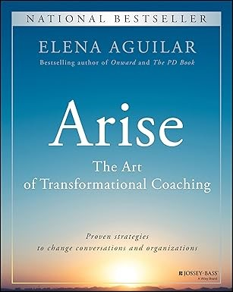
Whether or not “coach” is in your job title, if you are any kind of school leader, I think you need to know about Elena Aguilar’s latest book, Arise: The Art of Transformational Coaching.
Coaching is one of the greatest levers to improve your school. And yet I know I didn't do it effectively when I coached teachers. I focused almost entirely on coaching teachers’ BEHAVIORS. For example, I would suggest teachers add more wait time or have kids work in groups. And what would happen? Inevitably I’d observe again and see lecturing and no wait time.
Elena has a much more thorough approach to coaching — in fact, a transformational approach — that comes from research and her own decades of experience. She suggests we coach the “3 Bs” — not just behaviors, but beliefs and ways of being, too.
Plus, a key purpose of her approach is to help teachers thrive. She shows you how to address teachers’ core needs so they can be more receptive to coaching and improve their teaching.
I am deeply impressed by how powerful and targeted Elena’s approach to coaching is.
Here are my resources for you this month:
• My full summary of Arise: The Art of Transformational Coaching with my PD ideas for you to improve your own coaching
• My 1-pager to give you an idea of what’s in the book
• My informative podcast conversation with Elena about the book to inspire you and give you concrete strategies you can use tomorrow in your work with teachers
February is Black History Month. Google just took this important event off of our calendars, but that can’t stop us from celebrating it. Take care of yourself and I'll be back in your inbox on March 15.
P.S. To learn more or get the book, click here: Jossey-Bass

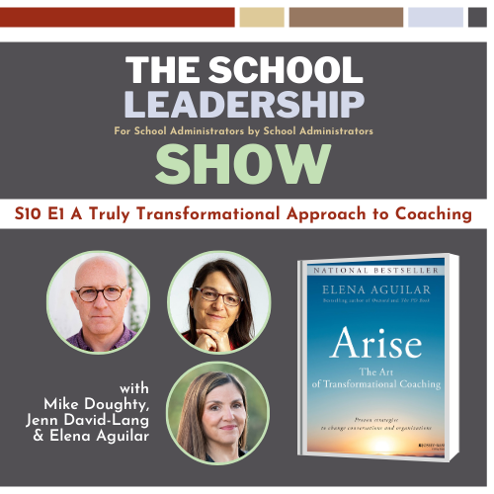
Free 1-hour workshop with Jenn
Retain & Re-Energize Your Teachers
Join me Wednesday, March 5, at 4-5pm ET (1-2pm PT).
This will be an interactive, virtual session. Come prepared to participate and I promise you'll leave with concrete strategies.
RSVP here: Workshop on How to Retain & Re-Engergize Your Teachers

My monthly newsletter is just the tip of the iceberg.
Want help dealing with difficult staff?
Want to get more organized this year?
Want to improve the effectiveness of your teacher teams?
Go to my online library of over 200 books and search these topics to find just the book summary you need for your challenge.
USE THIS PASSWORD:
readingislife (all lowercase)
LOGIN NOW
***Quick Request: Would you take 1 minute to give me some FEEDBACK so I can improve THE MAIN IDEA? Feedback for Jenn
Contact Jenn David-Lang at jenn@themainidea.net

