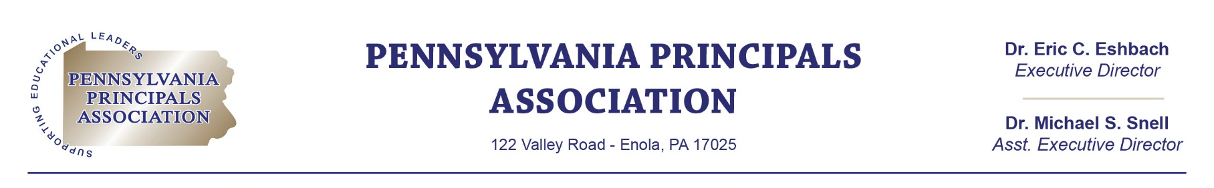

May 1, 2023

Keith Jorgensen
617 W. Stolley Road
Grand Island, NE 68801

Dear Keith:
On behalf of the Pennsylvania Principals Association, I want to thank you for being a long-time Diamond Level Sponsor of our organization. The contribution Kades-Margolis Corporation made of $20,000 last year allowed the Pennsylvania Principals Association to provide professional development, legal assistance, and advocacy for the nearly 3,300 members we serve.
According to our records, the Agreement for this sponsorship level expires on June 1, 2023. We truly hope that you will continue your support and wish to renew your commitment with the attached Agreement for another year. Please sign and return this agreement at your earliest convenience. For your convenience, we have enclosed an invoice for you to process payment for this sponsorship.
I have also attached the updated Corporate Sponsorship Card, outlining the opportunities provided for the Diamond sponsorship level. We updated our sponsorship levels, thus there are other additional opportunities available to you such as receiving more “face-time” with our board and members. If you have any questions or suggestions, please feel free to contact me at (717) 732-4999 or msnell@paprincipals.org
I look forward to continuing our partnership in the future!

Sincerely,
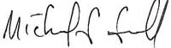
Dr. Michael S. Snell
Assistant Executive Director

