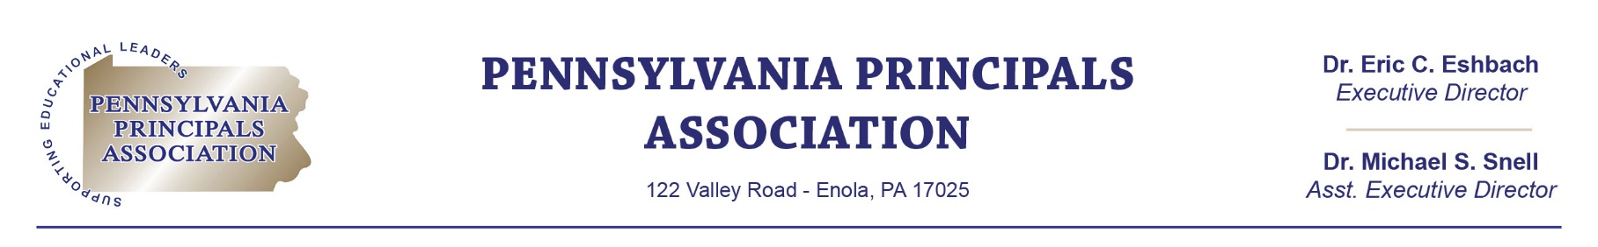

May 19, 2022

Bernard Shaughnessy
203 Woodbridge Court
Canonsburg, PA 19004

Dear Bernie:

On behalf of the Pennsylvania Principals Association, I want to thank you for being a Silver Level Sponsor of our organization. The contribution Jostens made of $5,000 last year allowed the Pennsylvania Principals Association to provide professional development, legal assistance, and advocacy for the nearly 3,300 members we serve.
According to our records, the Agreement for this sponsorship level expired on April 9, 2022. We truly hope that you will continue your support and wish to renew your commitment with the attached Agreement for another year. Please sign and return this agreement at your earliest convenience. We will then issue an invoice for you to process payment for this sponsorship.
I have also attached the Corporate Sponsorship Cards, outlining the opportunities provided for each sponsorship level. We are in the process of reviewing and updating our sponsorship levels, thus there are other additional opportunities available to you such as participating in our “3 in a Quarter” podcast and receiving more “face-time” with our board and members. If you have any questions or suggestions, please feel free to contact me at (717) 732-4999 or msnell@paprincipals.org
I look forward to continuing our partnership in the future!

Sincerely,
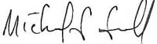
Dr. Michael S. Snell
Assistant Executive Director

