How to Access Your Account

Welcome to the new PA Principals Association website! Since you were already a member of the old site, this transition should be easy for you.
Existing membership accounts have been transferred to the new membership management platform Wild Apricot. You will now use your email address and a password of your choosing to log in. To set your password, visit this link and enter the email address associated with your account:
https://ppa13.wildapricot.org/Sys/ResetPasswordRequest

This will have the system send you an email containing a link to reset your password. Once you have clicked the link and reset your password, you can login to your account at paprincipals.org and access additional materials that are only available to members, as well as manage your own account through the “My Account” tab.
Your initial password:
- Visit https://ppa13.wildapricot.org/Sys/ResetPasswordRequest
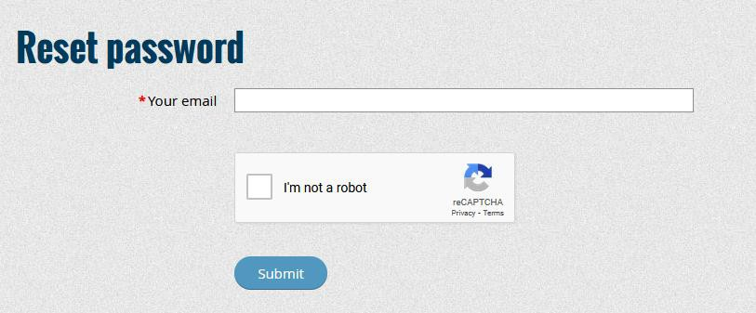
- Enter your email address
- Wait to receive the password reset email
- Once received, click the link in that email to set your password
- Now, visit paprincipals.org, where you can click the “Member Login” button and enter your email & password to access your member account


If you ever need to reset your password again, just follow these steps:
- Go to PAPrincipals.org website
- Click on “Member Login” in the upper right of the homepage
- Click the “Forgot Password” link below the login boxes
- Enter the email address associated with your PA Principals account
- You will receive an email with a link to reset the password to your account
  - If you do not receive it within a few minutes, be sure to check your Junk or Spam folder incase it was sent there by your email provider since it was an automated message.
- Click the link within the email and reset your password
- Now with your email address and updated password, you can click the “Member Login” and
access your member account
  - While logged in, you will be able to access materials not available to regular website visitors as well as manage your account and profile.

