PLEASE DUPLICATE & DISTRIBUTE TO: PRINCIPALS, ASSISTANT PRINCIPALS, SUPERVISORS &

CENTRAL OFFICE ADMINISTRATORS

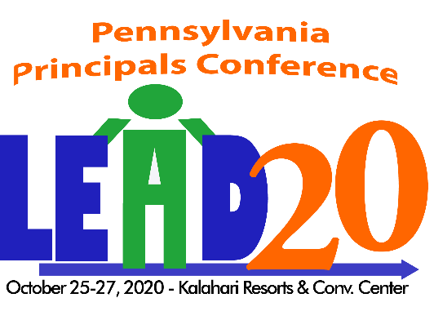

CALL FOR PRESENTERS

Breakout sessions are 60 minutes in length and must be on at least one the following strands:
(Please check the one at applies)

☐ Strategic/Cultural Leadership
☐ Systems Leadership
☐ Leadership for Learning
☐ Professional and Community Leadership

Print or Type:
PLEASE NOTE: All information must be completed to be considered.

(Title of Presentation)

List Presenters – primary person first (person to be contacted by the committee – Primary contact will keep other presenters informed of acceptance and other details): (Dr., Mr., Mrs., Ms., title, Sch. District/Organization)

NAME OF PRIMARY CONTACT TITLE CELL PHONE #

NAME OF SCHOOL DISTRICT/ORGANIZATION FULL ADDRESS

E-mail Address

Signature of Primary Contact
Describe your presentation in 1 or 2 paragraphs.

Describe how your workshop is related to one of the 4 strands. (Strategic/Cultural Leadership, Systems Leadership, Leadership for Learning or Professional and Community Leadership)

Please list two or three of your workshop’s goals or objectives.

Who is your target audience? Check all that apply.

☐Elementary ☐Middle Level ☐High School ☐Central Office ☐New Administrators
Workshop Format (lecture, hands-on, etc.):

NOTE: Speakers must provide their own laptop, projector, cables, etc.

- If selected, will you provide an electronic copy of a handout to be distributed to participants prior to the conference?
☐Yes ☐ No

- If selected, do you give your permission to have the session taped for streaming? ☐Yes ☐No

Once all submissions are reviewed, the program committee will select those programs that most appropriately meet the needs of school administrators.
**SUBMISSIONS WILL NOT BE ACCEPTED FROM COMPANIES/ VENDORS**

Email completed form to: Stephanie Kinner - Program Committee, PA Principals Association,
E-mail – kinner@paprincipals.org

DEADLINE FOR RECEIPT OF PROPOSALS – Tuesday, March 24, 2020

