PLEASE DUPLICATE AND DISTRIBUTE TO:

Central Office Administrators, Principals, Assistant Principals, Supervisors, IU Staff

CALL FOR PRESENTERS

2018 PENNSYLVANIA EDUCATIONAL LEADERSHIP SUMMIT
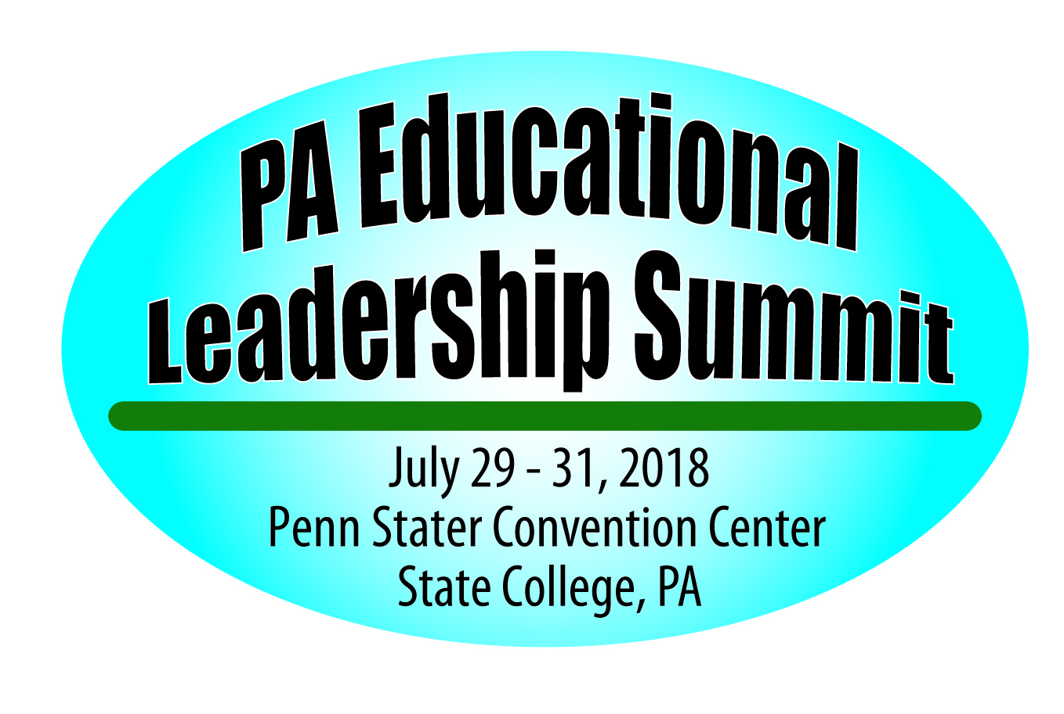

Penn Stater Convention Center
State College, Pennsylvania

Breakout sessions are one hour and fifteen minutes in length and must be on the following strands:

Strategic/Cultural Leadership (vision, goals, leading change, using data, building an
empowering culture)

Systems Leadership (expectations for all, school safety, resource
utilization, mandates, communication)

Leadership for Learning (leading initiatives, aligning curriculum, high quality instruction, maximizes times)

Professional and Community Leadership (professionalism, engages
community, supports and models professional growth)

Print or Type:
All information must be completed to be considered.

____________________________________________________________________________
(Title of Presentation)

List Presenters – primary person first (person to be contacted by the committee – will keep other presenters
informed of acceptance and other details): (Dr., Mr., Mrs., Ms., title, School District/Organization)

_____________________________________________________________________________
________________________________________________________
________________________________________________________
________________________________________________________
___________________________________________________(______)_____________________
Name of Contact Person Title Phone #

_________________________________________________________________________________________
Name of School District/Organization Full Address

E-mail Address _____________________________________________________________

Signature of Contact Person ___________________________________________

Describe your presentation in about 1 or 2 paragraphs.

___________________________________________________________________________________________
___________________________________________________________________________________________
___________________________________________________________________________________________
___________________________________________________________________________________________
___________________________________________________________________________________________
Describe how your workshop is related to one of the 4 strands. (Strategic/Cultural Leadership, Systems Leadership, Leadership for Learning or Professional and Community Leadership)

___________________________________________________________________________________________
___________________________________________________________________________________________
___________________________________________________________________________________________
___________________________________________________________________________________________

Please list two or three of your workshop’s goals or objectives.

___________________________________________________________________________________________
___________________________________________________________________________________________
___________________________________________________________________________________________
___________________________________________________________________________________________

What is your target audience? Check those that apply.

____District Leadership ____Building Leadership ____Curriculum/Supervisors/IT
____IU

Workshop Format (lecture, hands-on, etc.)

___________________________________________________________________________________________

Audio-Visual Needs- Screens will be available. Other equipment you must provide.

Will you have handouts for your participants? _____ Yes _____ No

Once all submissions are reviewed, the program committee will select those programs that most appropriately meet the needs of participants and pertain to the theme of our conference.

Submit completed form to: Dr. Paul M. Healey, Executive Director, PA Principals Association,
122 Valley Road, P.O. Box 39, Summerdale, PA 17093
O Fax (717) 732-4890 O Phone (717) 732-4999.

DEADLINE FOR RECEIPT OF PROPOSALS - February 23, 2018.
Please Note: We are not accepting any vendor presentations.

