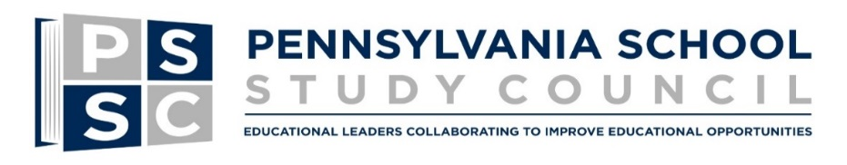
presents:
STEM 2018

Tuesday June 19, 2018 from 9:00 AM to 3:00 PM including lunch at
the newly remodeled Conference Room of the Centre County office of Central IU10 in State College
Registration will begin at 8:30 AM
Registration fee includes hands-on instruction, collegial learning, materials, ACT 48 hours, lunch and parking

Morning Presentation
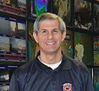

Welcome and ‘Why are we here’ by Dr. Jon Nese,
Professor in Meteorology, writer and host for WPSU Weather World
Dr. Carla Zembal-Saul – Professor of Education in Science Education and holds the Kahn endowed professorship in STEM education at The Pennsylvania State University. Her research investigates the development of teaching practices that support K-6 children's participation in authentic scientific discourse and practices. The purposeful integration of technology tools has played a central role in her teaching and research. Co-author of NSTA’s Next Generation Science Standard Dr. Zembal-Saul will address the State of STEM Learning and provide an activity that always “pleases the crowd”

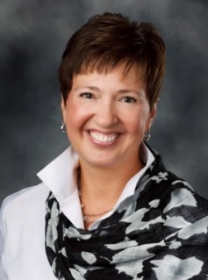

Afternoon Session will feature a “Showcase of Schools” in which all participants will rotate through a minimum of five examples of STEM type instruction (schools and topics to be announced).
Judd R. Pittman – Special Consultant to the Secretary of Education on STEM at Pennsylvania Department of Education. Judd R. Pittman is an advocate for public education. Judd was an educational consultant at the Pennsylvania Training and Technical Assistance Network (PaTTAN) where he focused on professional development and technical assistance for educators and administrators. Judd has a diverse educational background with a degree in Ecology from Juniata College, a Master’s in Forest Ecology from Virginia Tech University, and a Master’s in Multi-Cultural Education from Eastern University.

- Aquaponics - Public/Private Partnership / STEMisphere / Coding /
- Implementation for students with IEPs (already scheduled)
- Ideas to replicate and implement at your school
- Presentations from Upper Perkiomen SD, Hanover Public SD, + drones
Steelton-Highspire SD, Carnegie Science Center and Penn State
- Come learn how you can present at future events too
STEM 2018 is designed for: Teachers from K-to-High School, Teacher Leaders, Principals, Curriculum Directors,
Central Office personnel responsible for implementation and supervision of science instruction,
and those Teacher Leaders guiding their school’s science development

STEM 2018 Presentation Registration: (Fill out one form per attendee)
Name:
Email: | Phone:
District:
Position:
Registration fee for PSSC Members*: $89.00  Non-Members: $99.00  Additional same-district registrants will be discounted $10.00 |  | $
TOTAL TO BE PAID: |  | $
If you are using a PO Number**, please indicate#: |  | PO:
Business office contact name: |  | Phone #
Business office contact e-mail:

*Member benefit can be applied if not already used
Act 48 hours will be available upon request and completion of documentation
Directions will be sent to the email of the identified registrant in the week prior to the event

**Please email registration and PO information by Friday 6/8/18
(check can follow at a later date with PO#*) to:
PA School Study Council
200 Rackley Bldg
University Park, PA 16802
Tel: 814-330-6312 FAX: 814-865-0070
Email: dns5077@psu.edu

Please Note: Cancelations (of less than 72 hours) and “no shows” will be charged the full registration fee

Penn State encourages qualified persons with disabilities to participate in its programs and activities. If you anticipate needing any type of accommodation or have questions about the physical access provided, please contact Danielle Nattermann, dns5077@psu.edu in advance of your participation or visit.

